**Part 4: Homepage application and main page of Authoring Tool of the cultural organization.**

The application available for mobile devices offers 4 different types of entertainment that correspond to 4 different games. At the beginning, the user has to 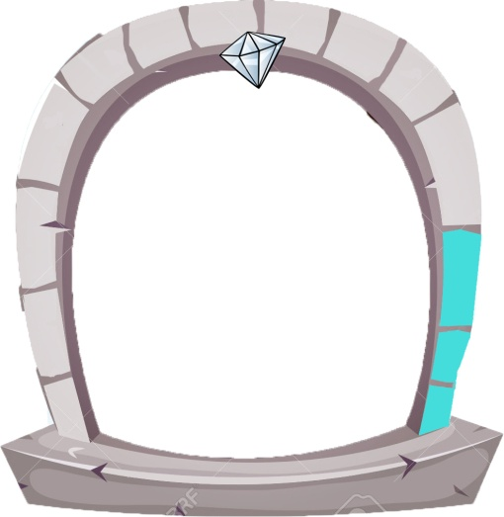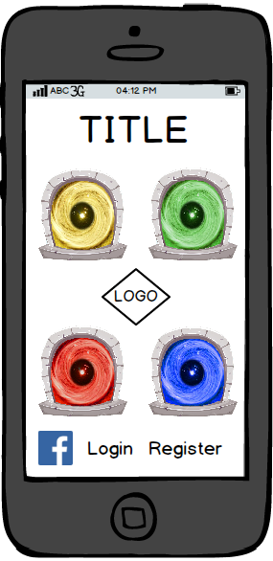register through credentials as a nickname , e- mail and password and he can also login thanks to the connection to social platform such as Facebook. Down here it is shown the idea of homepage. It’s characterized by 4 portals and each one of them has a different background colour and some imagines that recalls the content and the theme of the game. Under these portals, on the left, there will be one or more clickable icons used to allow access through social networks and also used to offer the possibility to share the screen and to show specific goals that will be explained later. The yellow icon is the "Treasure Portal" that allows access to a game based on the treasure hunt. The green one is the " Travel Portal " linked to the visit of cultural property throughout the national territory. The red one is the "Puzzle Portal " in which you read stories related to myths and legends to be solved. Finally there is the blue one that’s called the "Knowledge Portal". this icon allows you to get information and write your own reviews about the places you visit .

Each icon is made by 14 stone bricks that enclose the whole arch. With the accomplishment of particular goals, the bricks will enlighten showing an advance of "level" by the user in a particular category. At the end of the 14 missions, the user will get a gem that will appear above the portal as an identification of the most skilled players .

Furthermore, whenever it is reached a certain number of lighted brick , it is possible to unlock a certain "title" that can be put next to the nickname (of course it can be seen from the other ) .

Each title is related to the theme of their category and allows you to highlight the qualification in one of four games. The titles and the levels in which you can take them follow this table :

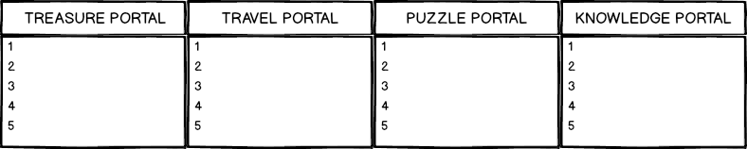

Because each cultural heritage could be included in each of the 4 games , it is required a web platform that allows the entity responsible for managing the tourist spots under its responsibility , to include them within the games and update and change information and content. The main page of this authoring tool is shown below :

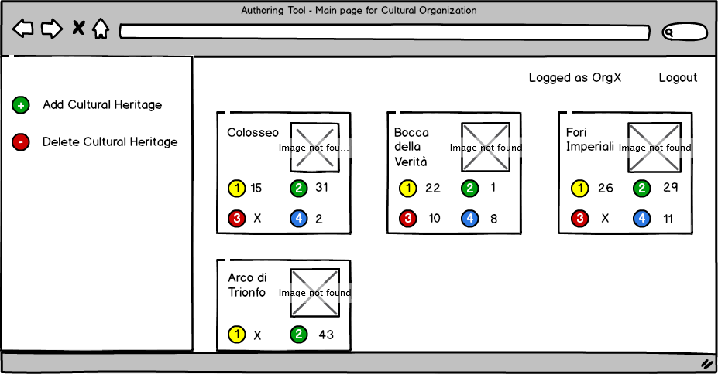

The screen is divided into two parts: on the left there is a menu in which the administrator can add or remove cultural property that he manages. This cultural heritage can be seen on the right side of the screen through an intuitive layout where each "card" represents one of them.  
Each card shows the name and the photo of the heritage site as well as 4 icons with a number representing the games where you can find this structure beside the users who participated (obviously if a cultural object has an " X " next to the number of a particular game , it means that the game is not yet available for this particular structure).   
In case you want to add a new cultural property ( and so create the " card" on the right ) , it is necessary to click on the green icon on the left and it will open a window that allows you to add the required information :

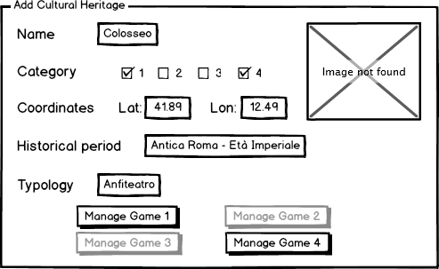

First of all you must enter the name of the structure and load the image , then enter the geographic coordinates (latitude and longitude) , the historical period and type. These information will be used within the games to which the structure belongs , games that can be decided by using checkmarks in the "category" section and that can be managed more specifically through the 4 bottom buttons that become selectable only if there is a match between the checkmarks inserted ( this will be better explained later ) .

Once completed the form, a card will be add on the right side of the main page;   
if you want to change something, you can simply re-enter the edit page by clicking on the card you want to change and you’ll see again the data that had been insert previously.

**Part 5: 1 game description and Authoring Tool of Treasure Portal**

The first game follows the dynamics of a treasure hunt. You can enter this game by accessing through the yellow portal and the mobile device is used to visit the place and the camera will allow you to search the treasure chests scattered in the building thanks to the virtual reality.

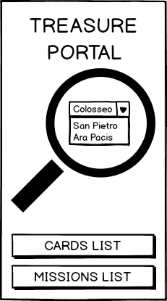Started the game there is a main screen that features three areas : the first is a menu choice that is placed in a hand lens. The menu will allow you to display the cultural property that are available for this Portal and select the one with which you wants to interact. The other two areas at the bottom can be accessed by two buttons that allow you to see management and visualization pages : the first is the one of the cards ( similar to the stickers ) , which are located inside the coffers , where you can see the progress of your own collection; while the other is the button for the missions list that shows particular goals in the game already completed or still to be reached ( for example : "collects 50 cards ," or " visit 10 cultural sites " etc ) . The goals will be those who will then enlighten the bricks around the Yellow Portal homepage, used to show the progress in this specific game . The user who is visiting a structure ( for example the " Coliseum " ) will search the "Coliseum" (inside the database of the application) by scrolling through the menu within the hand lens. Once found , click the name and go to a new page that provides the tools to carry out the " treasure hunt . " The new page is divided into four areas: in the middle we have an interactive map that shows the top view of the cultural property on which there are green and red dots points . They are used to indicate the location of the treasure chests in the building, the red ones indicate the treasures not found , the green ones point the chests discovered by the player.

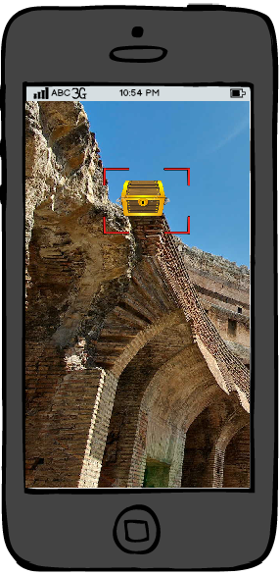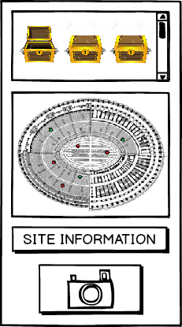Of course, once you find a new treasure , the map will change that point by changing its color from red to green.   
In the upper portion of ​​the screen there are all the chests that you can find in the area , those already discovered are shown as open , those still closed are the ones yet to be found (which correspond to the red dots on the map ). Each chest contains two elements : the information about the monument / place where it was discovered that can be seen directly within the application ( can give information on the entire cultural heritage or maybe a part of it , it can offer technical curiosities or curiosities about the historic period ) , while the other is a pack of trading cards ,the one mentioned before .   
Inside there are "virtual stickers" : each of them represent a picture of an Italian monument with a small description and some curiosity. Finding all the chests, the user has the possibility to open the packages to collect more and more stickers and he can view them thanks to the button shown in the previous screen. Instead the " site information " button leads to general information on the structure that you are visiting , a sort of portable encyclopedia that you can consult whenever you desired.   
But how do you find the treasures in a practical way? The answer is in the last icon, the one that shows a camera. This icon activates the front camera of your mobile device and the user needs to search the chest placed on the screen of your smartphone (through augmented reality) by framing the place where it is located.   
Once discovered , you must click on it to pick it up and open it. The areas of the dynamic map (which will modify the point from red to green) and the one of the treasures of the collection in the upper part will automatically be updated . Even in this game it is necessary a web platform that allows, the person in charge of the structure that adhere to the activity of the portal Treasures, to adding chests , hot spots on the site map and related information. For this reason within the main page, to which the cultural association can access with their credentials , there is the "Manage Game 1 "button that provides a set of services that allow the management of the game on the treasure hunt. Therefore a new window will open by clicking on this button:

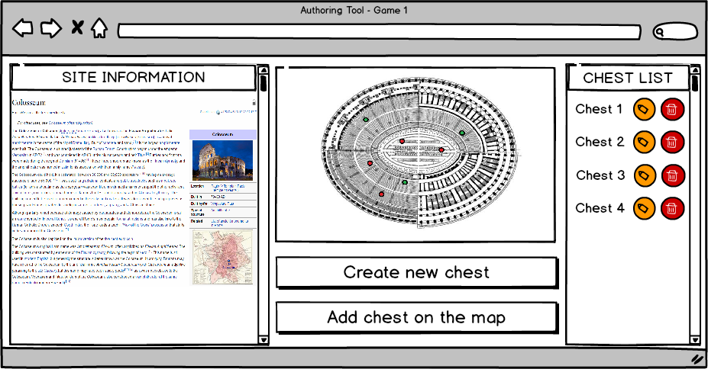  
In the left area under "site information " you can upload images and information that will be seen by users through the app on the smartphones. The map from the site will be interactive and through the tools it will be possible to create points and assigned the various treasures (thanks to the "add chest on the map " button ) ; for example, by clicking on the map you could automatically create the " hot spot " and through a drop down list you’ll be able to choose what treasure connect to the point. With the " Create new chest " button you will have access to a small window where you can put the desired information within the chest which will be saved and shown in the " chest list" area on the right side of the page.   
The window used to add the chest will be very simple : it will allow you to enter information and curiosity related to the treasure location and confirm your choices or cancel them through two buttons: "ok" and "cancel".   
The system will still assign to the chest the 5 collector cards , so this aspect will not be managed by the head of the cultural property that uses this management page.

**Part 6: 2 Game description and Authoring Tool of the Travel Portal**

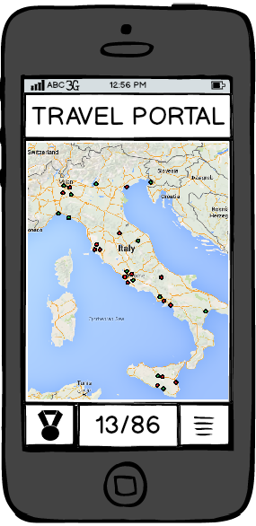The second game is accessible through the green portal . This game has as its central theme the journey and the visit of the cultural places all over the country. After clicking on the portal that is located in the homepage, the screen that will appear is divides into 2 areas. The first one, that is also the bigger one, is an Italian interactive map. This map is expandable and navigable and there is the possibility to zoom whatever place you want. The red dots highlight the culural structure that has to be seen, meanwhile the green dots represent the areas that the user had already seen (the system take note of the player position with the help of some service of geo-localization and thanks to the internet connection and the GPS of the mobile phone that must have these services on). The map automatically updates the points of interest thanks to the tools within the page managed by the head of the cultural heritage. In fact, when the "card" is created with all the data of the cultural site, it is also requiered the geographic coordinates where it is located. After that, this informations will be taken from the database by the application that manages the map and the points will be positioned on it. In the lower part, instead, there are two buttons and a central counter ; the latter shows the number of places visited and after the ”slash” there is the total number of the cultural sites. Meanwhile, the button on the left opens the medals collection page and the right one (with the horizontal lines) shows some placement in real time. For what concern the medals room, it collects three categories of this particular kind of goals; a medal is an achievement based on the number and especially on the type of places visited. They are divided into three groups : the first is related to the 20 Italian regions (in the picture there are Lombardy, Lazio , Sicily ) , the second contains medals related on particular historical periods (such as "Roman Empire" , "Ancient Greece" , "Middle Ages”) while the third describes the type of structure that can be visited (churches, castles or bridges ).   
At first every medals will be surrounded by a red circle, which means that they have not been conquered; when the user fulfill the requirements to gain one (for example to win the Medal of Lazio you must visit 15 cultural places within this region ) , the medal will be surrounded by the green color to symbolize that it is taken. Of course there will be the opportunity to share the achievements and so the medals, thanks to the sharing of the Medals room by connecting with social networks such as 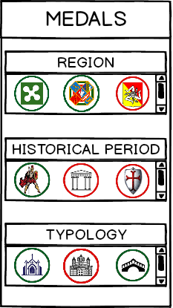Facebook or Twitter. For the classification page instead ( which is accessed by the button with the horizontal lines ) we have to do a distinction between three types of them. Each rank is automatically created by the system and the user who had visited more cultural places is placed higher up. The first type of classification ( for example called "general classification " ) will be made ​​between all subscribers to the application that use the game. The second placement instead shows only their own group of friends contacts (perhaps taken from the set of Facebook contacts). Meanwhile the third one is a bit more complicated. It is a rank among all users of the application with the difference from that this classification is updated every month / quarter / year by resetting all the scores of the participants to zero. With this placement at the end of the "season", for those users who will occupy the highest areas , there may be some "real" rewards such as promotions and discounts for entrance in other cultural places such as museums and guided tours.

**Part 7: 3 Game description and Authoring Tool of the Puzzle Portal**

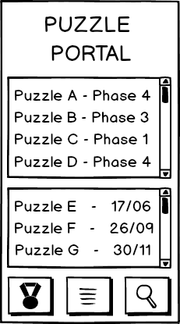The red portal allows the entrance in a game based on a series of puzzles, myths and legends. The player will have the opportunity to choose from lots of stories periodically proposed by the managers of cultural heritage and solve the mysteries by answering questions of logic and culture, collecting clues and observing in first person the places that are talked about in the stories. The management of an enigma takes place in this way: for example, the head of the Colosseum creates (through various pages with appropriate tools that will be provided) a story that deals with some mystery in Rome that took place right in the Flavian Amphitheatre.   
This story will be divided into 4 chapters and each chapter will propose a final question that must be answered by users. Each week will be turned on one part of the story , then we will wait another week to get the players' answers (filtering out the correct ones) and activate the next part until the end. The users, who were able to respond correctly to all 4 questions of history by completing the final resolution of the enigma, will then be rewarded with game trophies or rewards. It will be up to the workers to create fascinating and interesting stories (based, as said before, also on particular curiosity, on myths and legends of our Italian cities) to encourage people to travel exactly where the story takes place to find hidden clues and have special inspirations to assist them in answering questions and advance the story.

The main page of the game is structured in this way: there are two large tables in the center of the page and three smaller icons below them. In the first table there is a list of all the puzzles currently in progress on the national territory that also includes the phase of the history in which they are located. By clicking on an entry , the player will have the opportunity to enter the enigma page, read the story and try to answer the question. In the second list we find the list of puzzles that are scheduled.   
That because, in this way, the people can know in advance where the enigma will take place and so they will have the possibility to organize visits to places and cities described in the stories. The first icon on the left gives access to the goals page (either the one to conquer that the already achieved) that will be those that allow the illumination of the bricks around the portal homepage as previously explained (some examples of goals might be : " Solve 3 puzzles in Rome ", "Solve a puzzle first", "Solve puzzles in three different cities" etc). 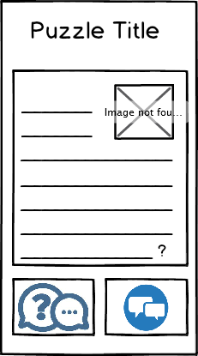Meanwhile the center button is useful to get the list of all the stories to which you have participated, including those still active ( maybe arrived to stage 2 or 3) to be more easily accessible without the need to look for them again in the big list of the main list. In the end, the right icon offers a search function to the puzzles : for example, a user who arrives in a particular city can immediately find all the events scheduled during the period of his stay by entering the name of this in the search function. This illustration represents the screen which can be reached by clicking on the individual puzzle shown in the list previously described. The story is told in the main frame, maybe even with the addition of photos and images; at the end of it there will be the question offered to players: as explained above, they will have one week to respond correctly and access the next challenge of the following week. Replies are sent through the bottom button on the left , while the bottom button on the right there is the possibility of access to a forum where other users interested in the mystery can discuss with each other, reach together the ultimate goal and comment the event.

To manage all this part of the application, is used again an authoring tool that allows the creation of stories, the creation of puzzles and an intuitive interface that gives statistical data on users' responses. The main page is divided in a way similar to the Cultural Organization page, and is then divided into two areas: on the left you have two buttons to create or delete previously written stories. On the right part there are cards that show the various events created by the makers of a certain group of cultural heritage; each card has the name of the story and an inherent photo, below them it is shown the number of participants and how many of them have managed to solve the proposed enigmas. Finally the status of the history up to that time is described (every event is divided into 4 stages, and each needs to be solved with a keyword; only after that it will be given the opportunity to solve the next puzzle).   
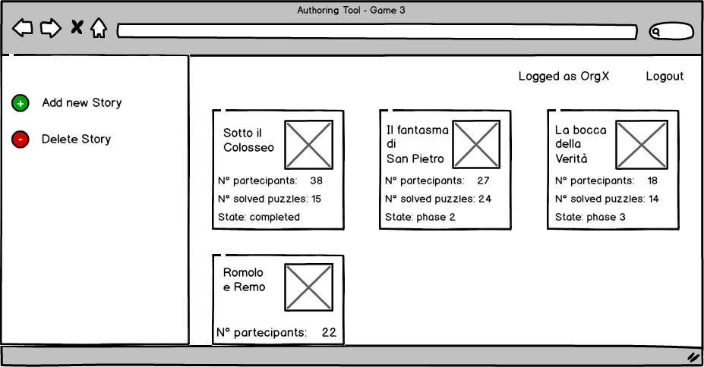

Let’s see what happens if you want to create a new story, by pressing the "Add New Story " button on the left of the page, a new window will open. This page will be divided into 3 areas: at the top you enter the name of the story and an identifying photo (which will be the one displayed in the authoring tool page ) , in the central part there are the four stages, each one with their three side buttons. The first button ("Manage") provides the access to a new window to create the individual enigma and set the correct answer , the second ("Start") allows an administrator to activate the week in which the puzzle is available : in this period of time, players can send their responses. The third one puts an end to this period and allow the creation and the beginning of the next phase of the story. At the end is the " Story Close " button that will end the event and allow the system to process the results to assign different objectives and awards achieved by users. The winners will be those players who have responded correctly on time to all 4 phases proposed. It is important to remember that the number of stages and their time duration are only indicative; many stories may require a greater or lesser number of puzzles or could be necessary more than a week to solve the mysteries proposed.

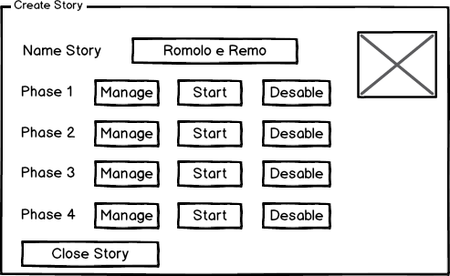

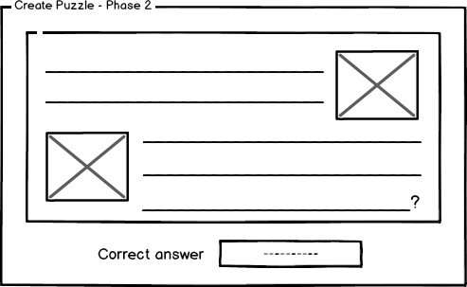 Here, the additional window, that opens after clicking on the "Manage", is shown. In the bigger space will be possible to insert the puzzle and all photos or clues connected to it, while the area below will used to enter the correct answer expected by the players. Once the user submit the answer with the app on the mobile phone, the system, through a parsing algorithm, will verify that it matches with the response written by the head of the authoring tool and if so the id user who gave the correct answer will notify in the database; in this way he will access to the following phases of history.

**Part 8: 4 game description and Authoring Tool of Knowledge Portal**

We finally can access to the fourth blue portal of the main page: the "Knowledge Portal"; clicking on it we will go to a page that allows you to collect and display the cultural information that we are visiting, having also the opportunity to judge the various reviews and comments from other users. The main page of this part of the application has a central zone and two buttons at the bottom; inside a book we find a list of places that adhere to the "game" and the user will have the option to choose the one you are interested in. With two buttons below, he can either display information on the choice you make, whether to publish or display the reviews on it. The person in charge at the cultural property management will place a sort of encyclopaedic page with trivia, photos and details of the place in question; you just accessed at it through the "explore" button. In addition to having all the necessary information in the new window that opens, a camera will be also in the lower part; clicking on,the front camera of the mobile device in use will launch and in this way it will be possible, through augmented reality, to frame the cultural object in front of you and learn more about the details of the structure that have a blue icon with an " i "in the center (such as paintings in a museum, special works in churches and monuments etc).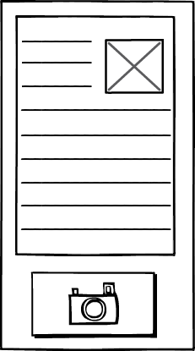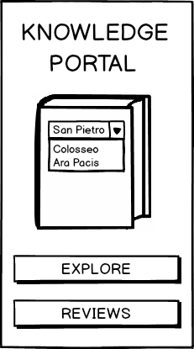

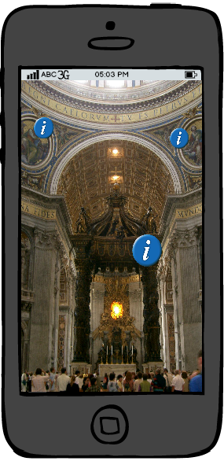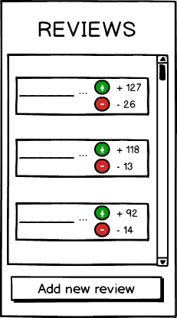With the "reviews" button of the Knowledge Portal homepage,you can instead open a window that provides written information directly from visitors; it collects reviews written by users thanks to the button "Add new reviews" and they are highlighted in the central area of ​​the page in a scrollable list that orders them from the one that has received the most positive votes at the one considered the most "useless." In fact the list is displayed in this way: alongside a preview of the review, there are two dots, one green that matches positive judgements of other users on your writing, and one red for negative judgments; you can simply vote the reviews by clicking on the respective dots. We can also create "objectives" and "missions" for the aspects of this section of the app even though it deviates more than the others from the concept of the game. For example you can reach a number of "info points" which have consulted, or an award for particularly talented and creative users, authors of a review that has raised more than all positive judgements, or other users that, visiting many cultural assets, have managed to produce a large number of reviews.

Even for this last part Authoring Tool web page is expected with which are handled on cultural information, info points and user reviews. It follows the main cultural organization page template being divided into two zones: a menu on the left and an area with a familiar tiles on the right. The menu at the top has a "List Reviews" button that allows you to access a page that displays all the reviews submitted by users in the application for a specific cultural site. From the window that opens, the manager can have statistical data on the comments and on the votes as well as having the opportunity to eliminate some reviews not related to the context or even unwelcome (even with the presence of coarse or offensive language). In the second area there are two buttons to create or delete "info point" that are placed for augmented reality; in the window that will open to the creation of a new info point, you must enter both the informational aspects that describe the item to which the point has to be connected and both the GPS coordinates that will then be used to position the tool in the physical space. Once you have created so the element, it will appear in the right side of the screen of the card assigned to it: inside each box the views of every point will also show for statistical and organizational purposes. Finally, always in the left side, at the bottom, there will be links to windows that allow you to write or remove the information pages relating to the cultural heritage 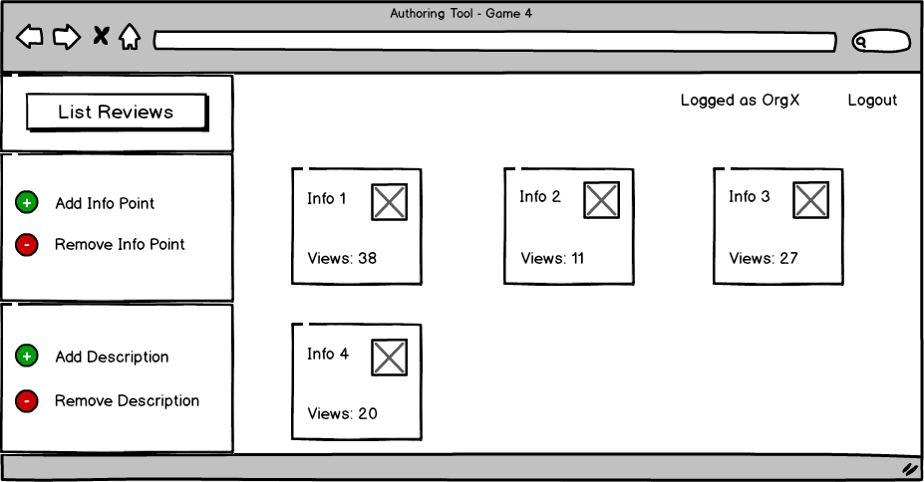then that will be displayed by the app users through the "explore" button.

**Part 9: Authoring tool Administrator page**

Up to this point we have described the general aspects of the application, the 4 games that make up , and web pages that enable the managers of cultural heritage to access and manage (through their credentials) only the points within their competence. In the authoring tool page is also possible to log in as the system administrator to view or edit the general aspects that are not relevant to the different cultural organizations. The administrator is the one who will oversee the application in all its entirety , taking a wider view of the entire operation. Down here the page, that provides the management tools and the description of each button of which it’s made up, is shown:

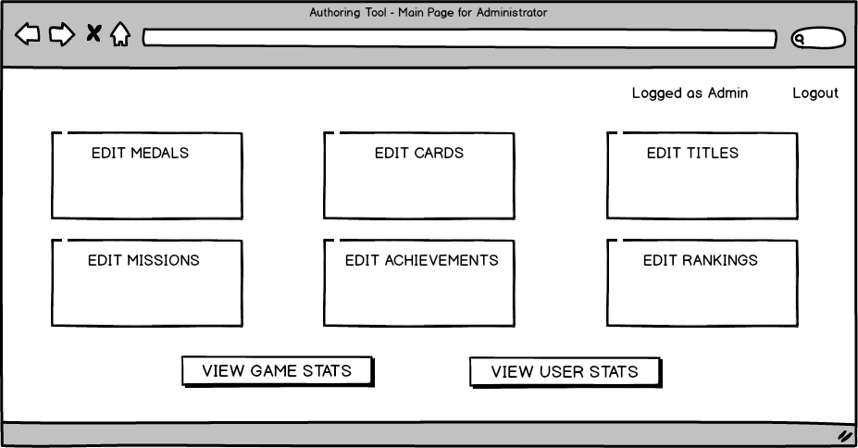

- EDIT MEDALS: It allows the opening of a window for the medals of the game 2 (the Travel Portal). It will be possible to create or remove medals or assign them different types from the ones that was given before, it will also be possible to change the parameters for the achievement of a particular coin (for example change the number of places to visit in a given region before winning the match trophy).

- EDIT CARDS: as already explained above, the cards in the chest Game 1 (the one of the portal Treasures) are managed entirely by the administrator. A set of cards will be created; this cards will be included in a random way inside the chests; to create a figurine you are going to need the tools that will allow you to add a photo identification of the monument representing and a brief description of it. There could also be invented some levels of rarity to find certain figure , there could be a "common", "rare" and "epic" depending on the probability of appearing within a chest. In the case of duplication it may be considered a mechanism that allows to "destroy " dual cards to receive the game coins that could be use to buy the missing cards (of course the cost to produce a card will be greater than the one gain by destroying one).

-EDIT TITLES: the titles are those that are won by completing various missions for each portal; as initially explained there are five levels in which it is possible to earn the right to put next to the nickname a new title that highlights the skill of the player in a given game. Since the games are 4 you will have a total of 20 titles available , and this button allows you to edit them or add other requirements for further goals.

- EDIT MISSIONS: of each game a set of missions (that periodically follow one another randomly) is created. A mission could be "visited the place X", "write a review", "find a treasure" and a new one a day is proposed to each user for a maximum of 3 accumulative missions . When the user performs a mission he could obtain gambling money useful for other purposes, or it may reach a particular "achievement " (which will be explained later). With the key of the mission management you add or delete tasks from the total set where then they will be taken randomly and proposed in the games to different users .

- EDIT ACHIEVEMENTS: The achievements are those challenges that will enlighten the bricks around the portal of a game to show the progress in a particular category. They are similar to the missions with the difference that they are more difficult to reach and above all they require more time. Some examples of achievements could be "win 5 medals region", "visit 30 cultural heritage in Italy", "write 100 reviews assessed positively", "complete 50 daily quests". The "edit achievements" button allows, as in the missions, to create or eliminate the achievements from the set that collects them all and in any case it will remain fixed for all players (unlike the missions that will be assigned randomly).

- EDIT RANKIGS: with this button it is possible to see the charts related to the game 2 (Travel Portal). There is also the opportunity to reset the monthly placement that will allow the winners to win real prizes like discounts and tickets for the entrance to certain cultural place. It will be a tool that will allow you to get in touch with the users of these promotions and update from time to time the available awards.

- VIEW GAME STATS: the statics are of significant importance especially the ones related to the games used to watch the attendance trends and evaluate changes or improvements. In the window, that will open by clicking on this button, there will be statistics on the 4 games such as the present number of cultural objects for each game, the number of cultural organizations that administer them, the arrangement of the places on the national territory etc.

- VIEW USER STATS: in the end, here you will have information on everything related to the players. Through the links with social network accounts it will be possible to traced back even the average target using certain games, which portals are the most played and how many people finish the missions that are required . Furthermore it will be possible to see how many users properly respond to the enigmas of Game 3, which chests are more open in the game 1 or what are the information points better exploited in Game 4.